COVID.

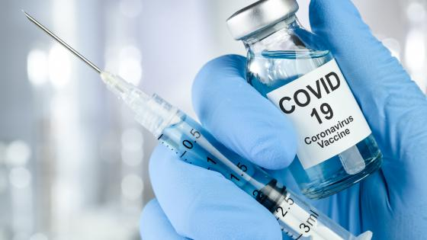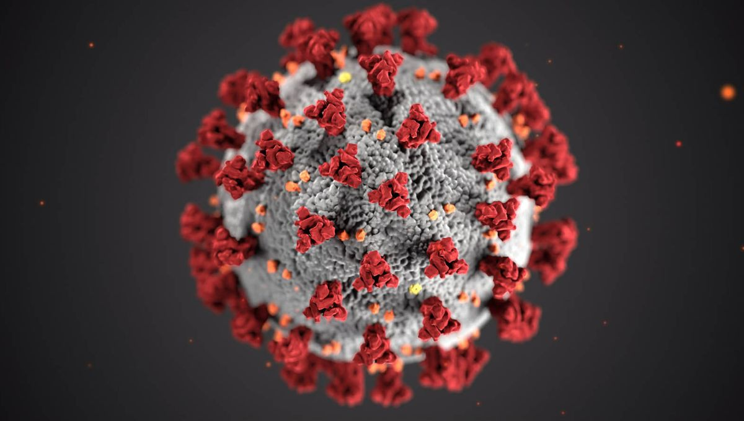

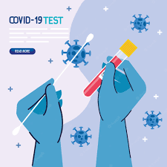 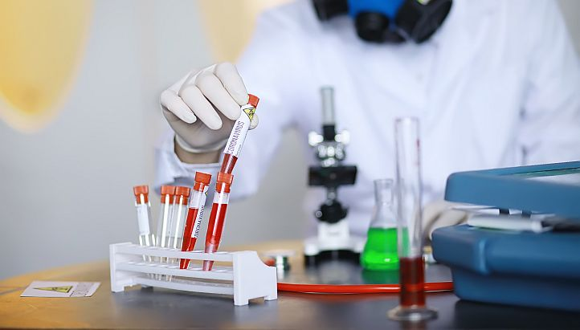

**E-PROJECT DOCUMENTATION**

**Faculty: SIR KHALID**

**BATCH CODE: 2111G1**

*COVID TEST AND VACCINATION SYSTEM*

COVID.

*User Guide*

**Project Group Member**

* **Sayed usman shams**
  + **Enrollment NO: Student1350098**
* **Sayed bilal shams**
  + **Enrollment NO: Student1350097**
* **Abdullah baber**
  + **Enrollment NO: Student1351346**
* **MUHAMMAD Sameer ghori**
  + **Enrollment NO: Student1350060**

**PROJECT DATES:**

Issue date: 12-Nov-2022

Submission date: 12-Dec-2022

1. **PATIENT LOGIN (LOGIN.PHP):**

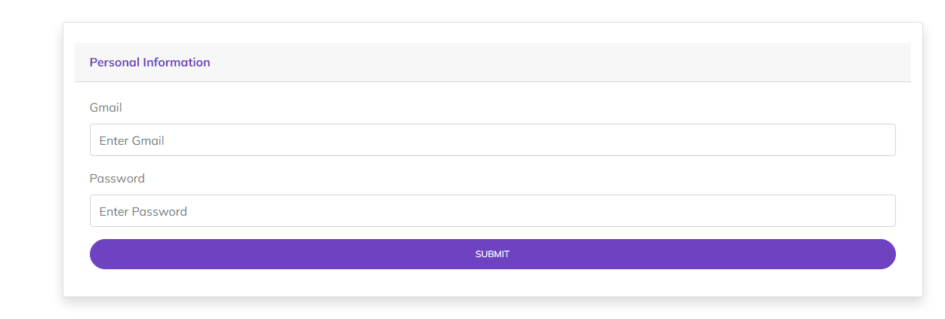

*Figure 1: Login page*

1. **PATIENT SIGNUP (SIGNUP.PHP):**

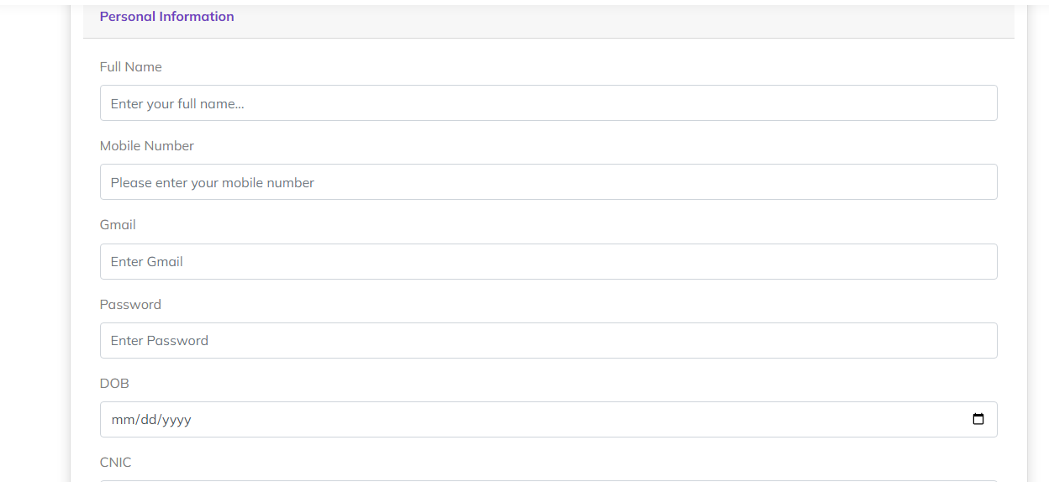

*Figure 2: Signup page*



1. **HOME (INDEX.PHP):**

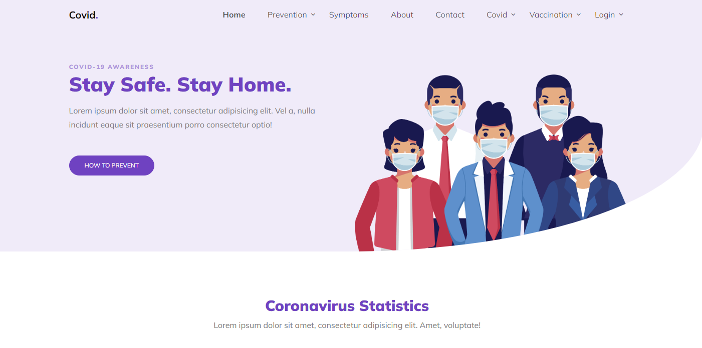

*Figure 3: Home page*

1. **NAVBAR (HEADER.PHP):**



***Figure 4: Navbar***

We have given seven essentials. By clicking any of the essential’s and redirect to the linked page.

1. **ABOUT US (ABOUT.PHP)**

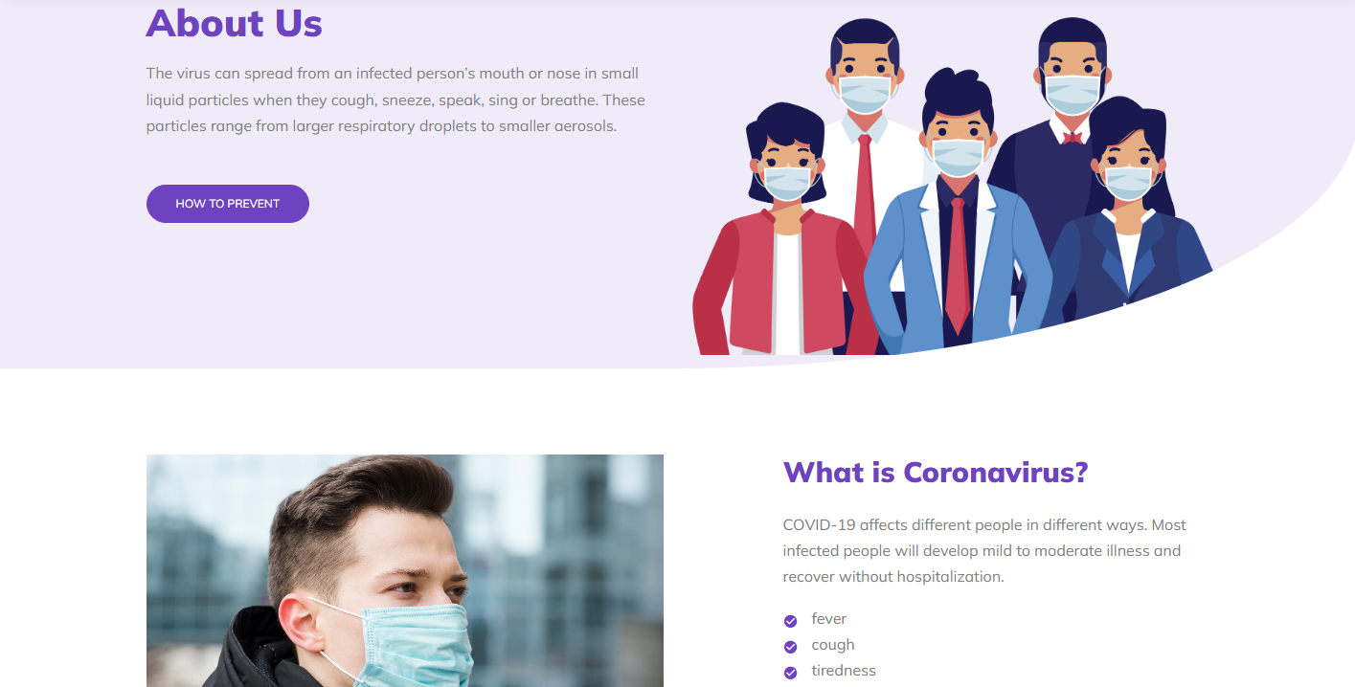

***Figure 5: About us***

**



** Explore different habitats, from the sweltering tropics to tidal rock pools.

** Discover all about our weird and wonderful creatures with fun and interactive learning experience.

**To be a destination of choice where all are welcome and motivated to join as a driving force for aquatic life.

1. **COVID APPOINTMENT (COVIDTEST.PHP)**

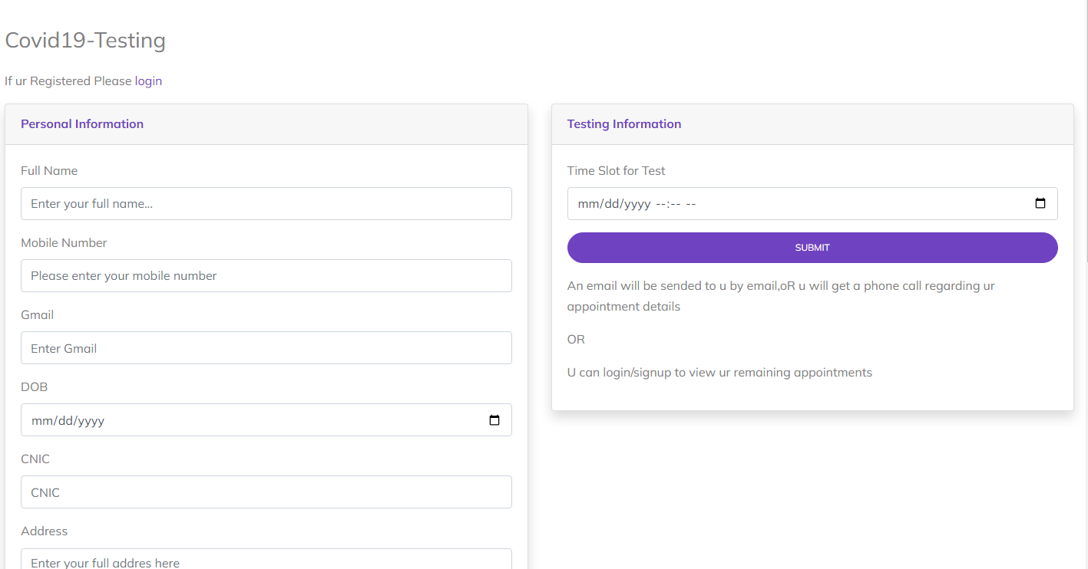

***Figure 6: Covid Test Appointment***

*We have mentioned our basic services to make people known about the service we provide.*

1. **SEARCH REPORTS(COVIDRESULT.PHP)**

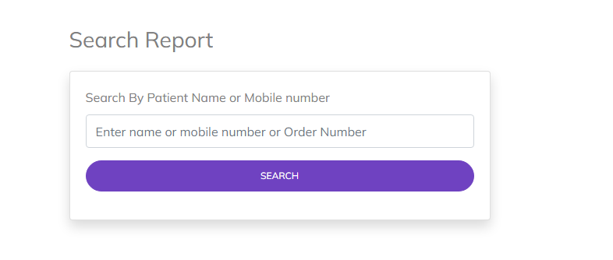

*Figure 7:Search Reports*

1. **Contact Us(contact.php)**

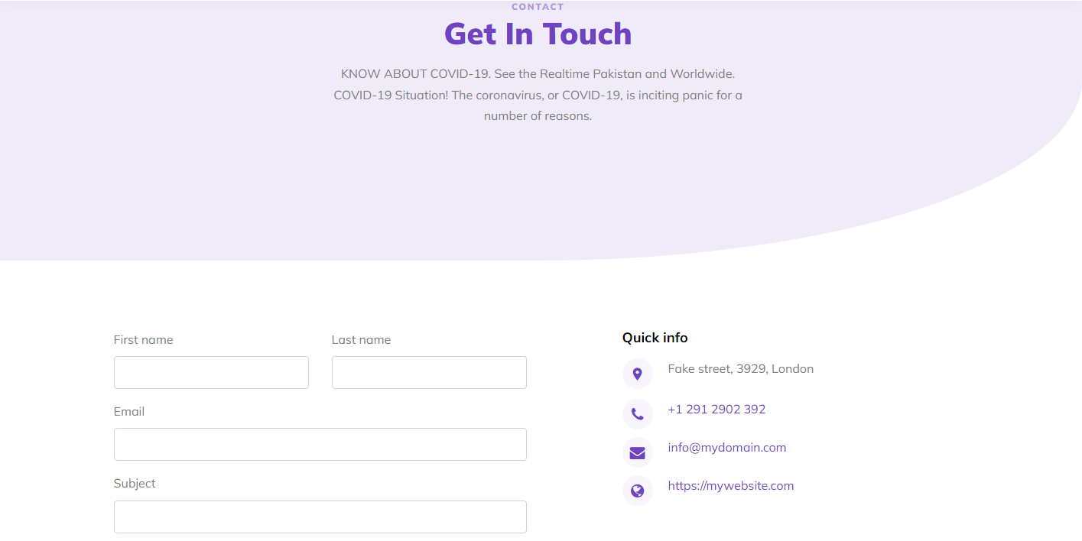



***Figure 8: Contact Us***

***9.* Available Vaccine(vaccine.php)**

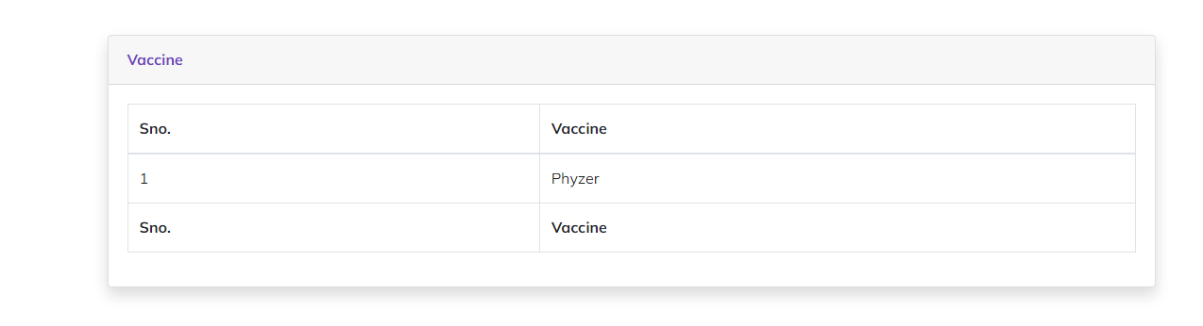

*Figure9:AvailableVaccines*

1. **Available Hospital(hospital.php):**

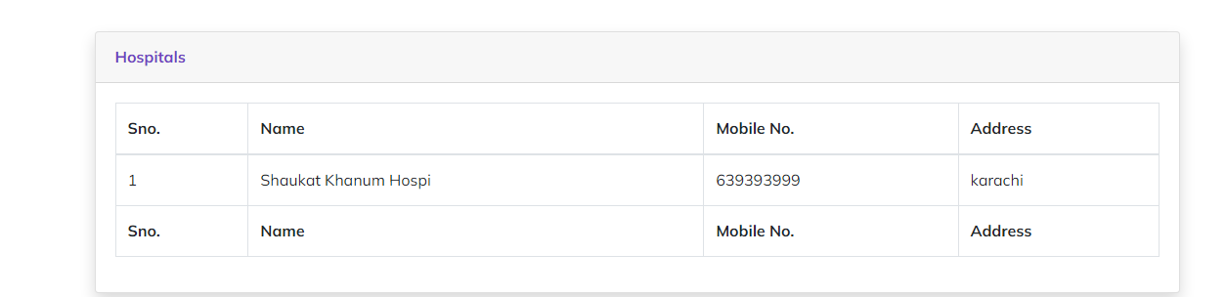

*Figure 10: Available Hospital:*

1. **Book Vaccination Appointment(vaccination.php):**

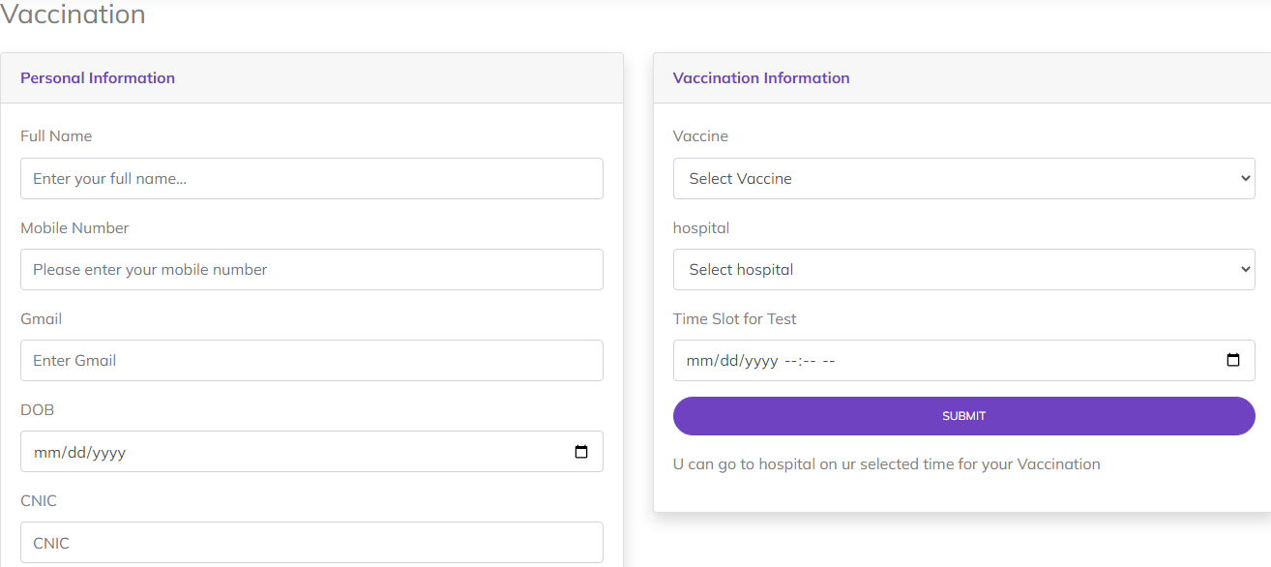

*Figure 11: Book Vaccine Appointment*

1. **Footer(footer.php):**

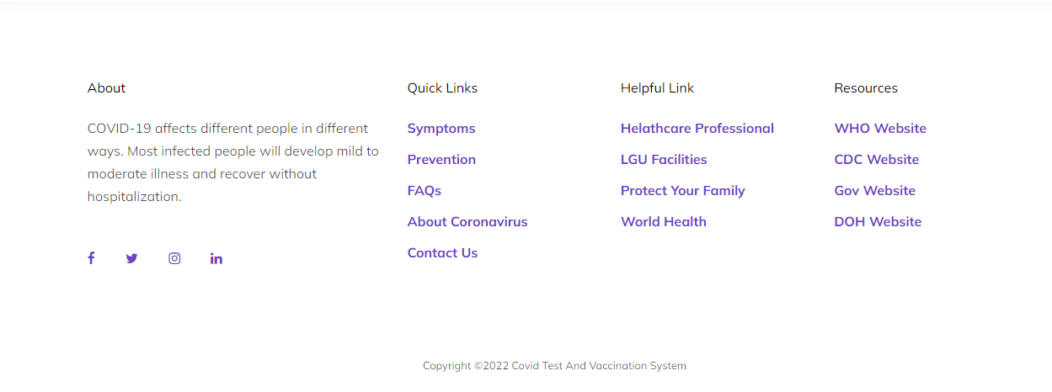

*Figure 12: Footer*

1. **Menu bar:**

***Use to load the remaining sections. The following is a list of those sections:***

*As we have work on only single page and re-directing on other sections. So, we are made our web directed pages.*

1. **Patient Login (login.php):**
2. **Patient Signup (signup.php):**
3. **Home (index.php)**
4. **Navbar (header.php):**
5. **About us (about.php)**
6. **Covid Appointment (covidtest.php)**
7. **Search Reports(covidresult.php)**
8. **Contact Us(contact.php)**
9. **Available Vaccine(vaccine.php)**
10. **Available Hospital(hospital.php):**
11. **Book Vaccination Appointment(vaccination.php):**
12. **Footer(footer.php):**

***BACKEND***

***BACKEND LOGIN PAGE(LOGIN.PHP)***

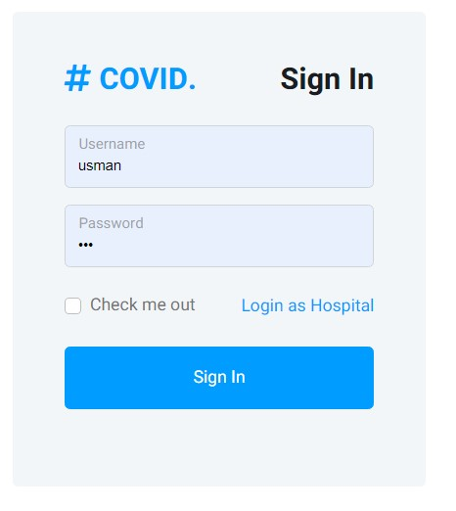

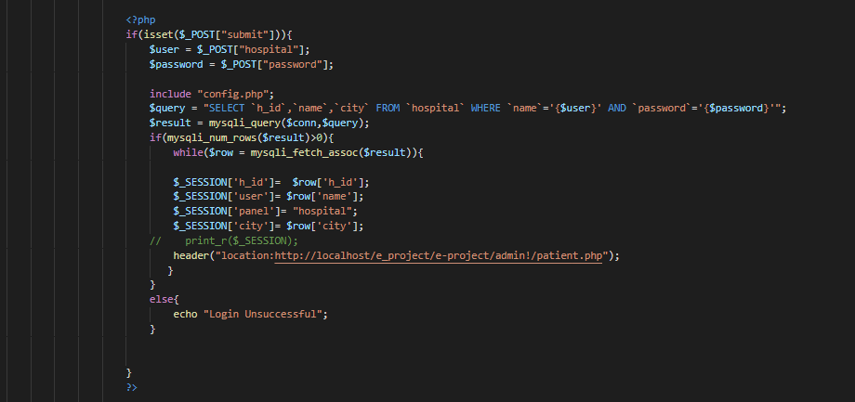

***BACKEND LOGIN PAGE(HOS-LOGIN.PHP)***

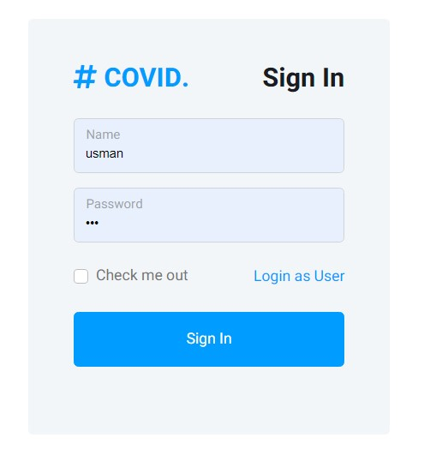

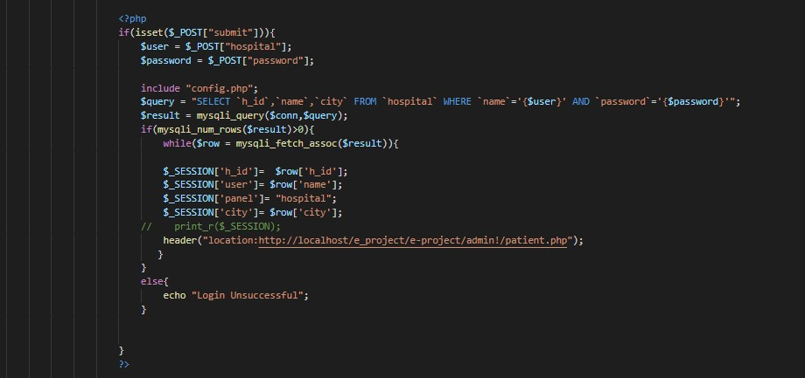

*Here you can login and login must required for enter the dashboard.*

***Dashboard (dashboard.php)***

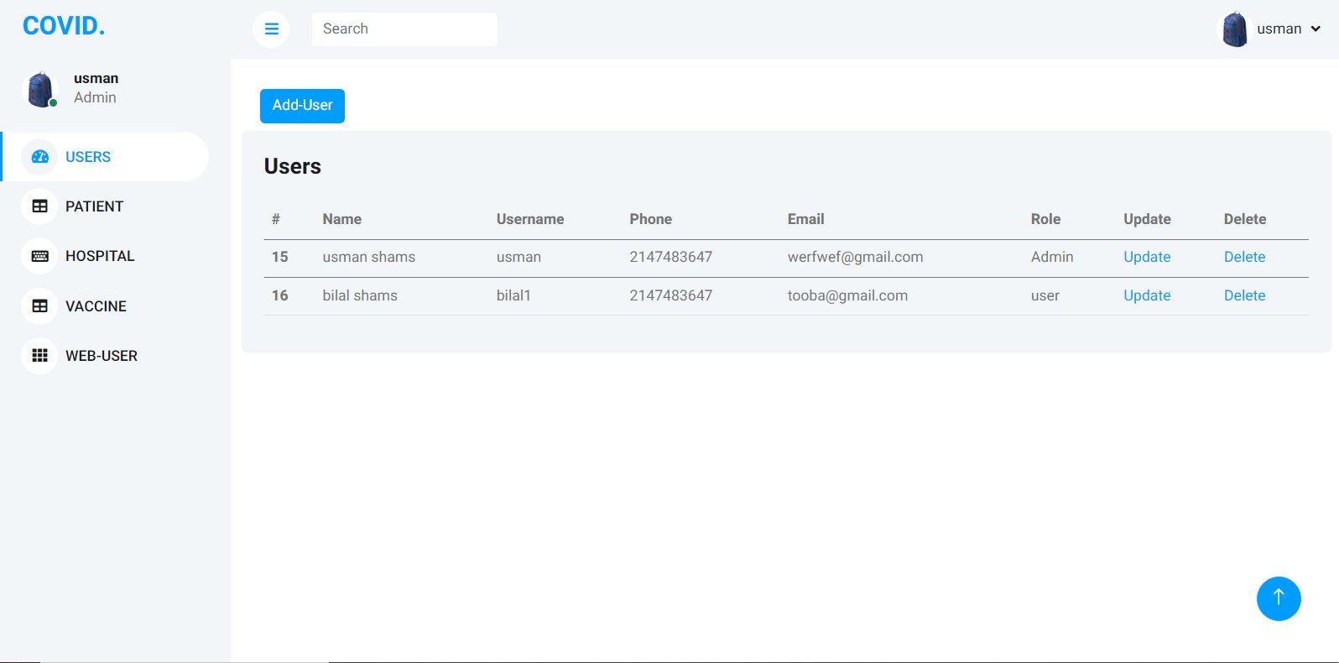

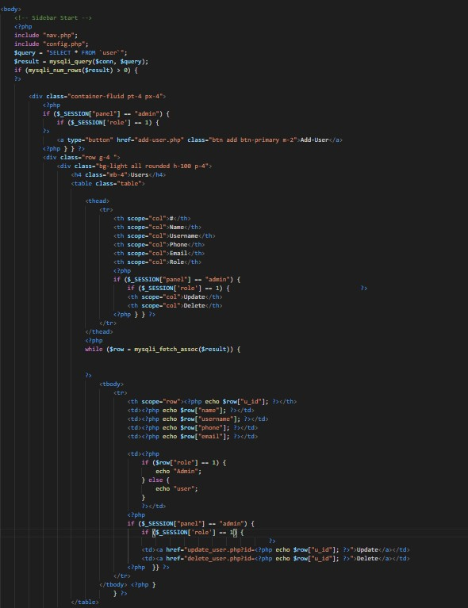

***Add hospital(addhospital.php)***

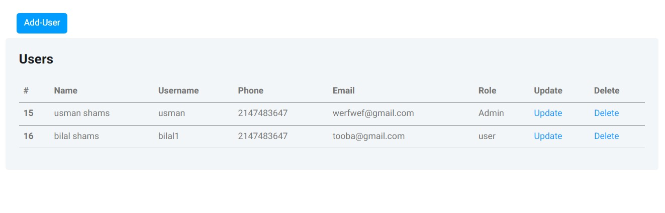

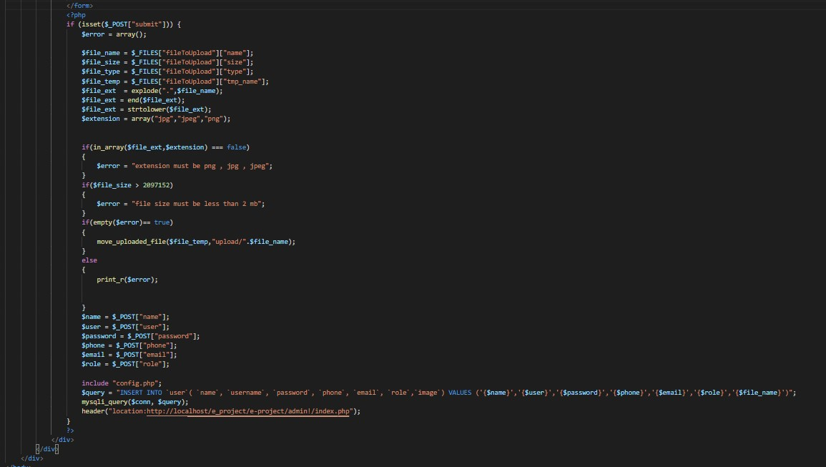

***Read hospital(Rhospital.php):***

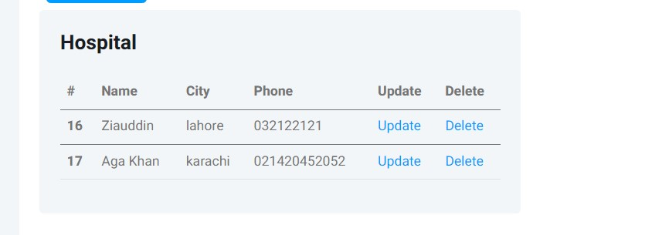

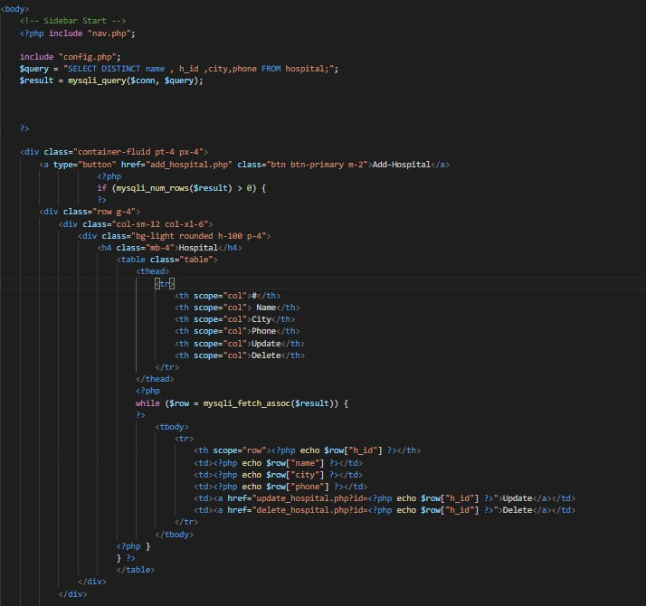

# Read Patient (RPATIENT.PHP)

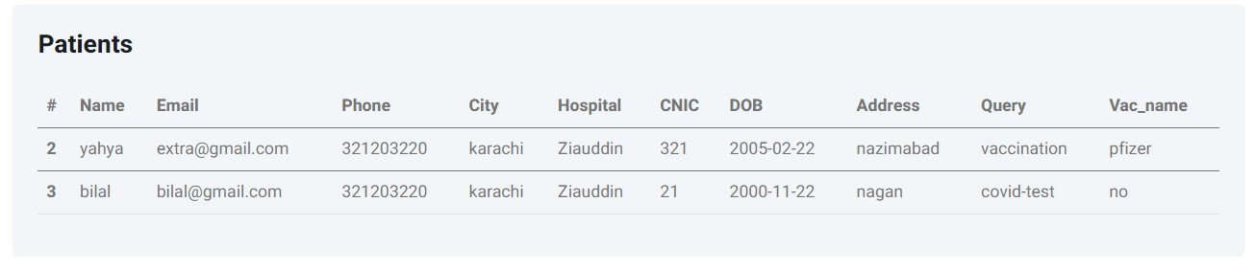

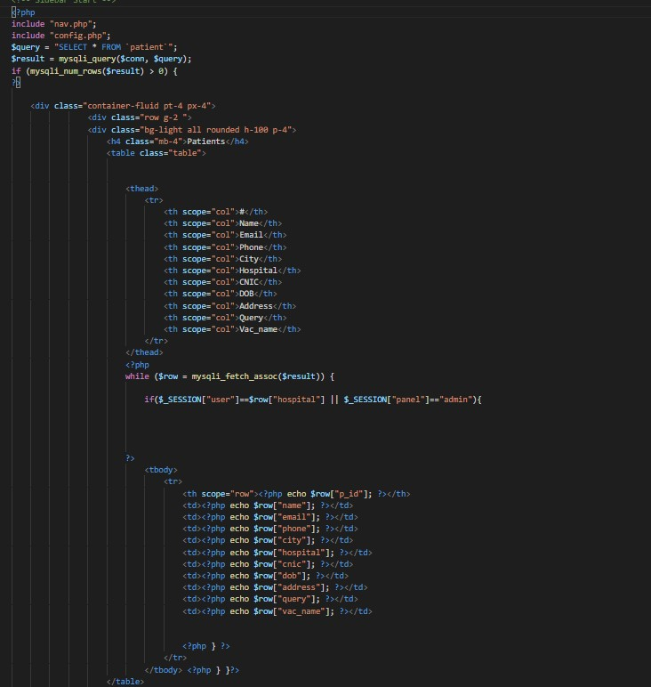

**ERD DIAGRAM(database/what.sql)**

`

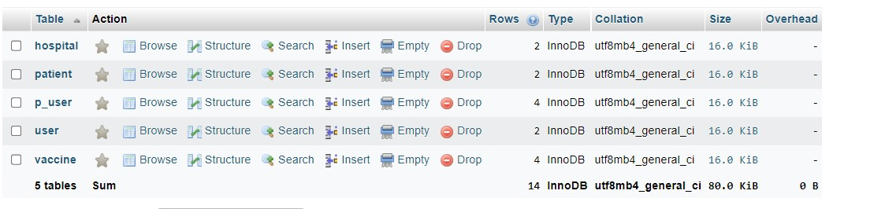

THANK YOU FOR READING THE

USER GUIDE.